We are now taking registrations of interest for the Summer 2020 Children Sailing Programme

Beachlands Boating club
The club has 6 Optimist sailing dinghies for learning to sail, two sprints for the larger kids, and a large 3 person Omega.
We also have 4 Stand Up Paddle boards, and 4 Kayaks, a windsurfer.
These toys are free to use for Members, and the Shed can be arranged by contacting a committee member.

Summer 2020 Children Sailing Programme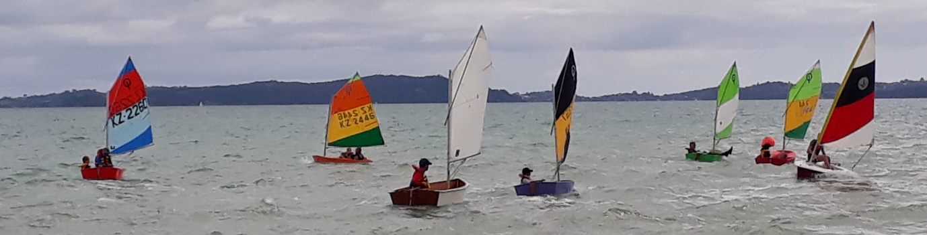
If your children are interested please contact roger.mayhill@xtra.co.nz
8 week programme starting November 2020
- Water and boat Safety
- Getting to know your boat setup
- Getting your boat in and out of the water
- Capsizing
- Tacking
- Gybing
- Points of sail
- Rules of sailing and racing

Sunday 15th Nov | Morning ( 10 am) | Meet and greet / Shed tidyup
Sunday 22nd Nov | Afternoon ( 1pm) | Intro to sailing – try it out
Sunday 29th | Morning ( 10 am) | Sailing with the wind on the side - beam course
Sunday 6th Dec | Afternoon ( 1pm) | Sailing into the wind – windward leeward course
Sunday 13th | Morning ( 10 am) | Sailing round a triangular course
Sunday 20th | Afternoon ( 1pm) | Sailing round a triangular course
Sunday 27th |  | Sailing a figure of 8 course – Give way rules

